BASAVARAJESWARI GROUP OF INSTITUTIONS



BALLARI INSTITUTE OF TECHNOLOGY AND

MANAGEMENT
NACC Accredited Institution
(Recognized by Govt. of Karnataka, approved by AICTE, New Delhi & Affiliated to
Visvesvaraya Technological University, Belagavi)
"Jnana Gangotri" Campus, No.873/2, Ballari-Hospet Road, Allipur,
Ballar1-583 104 (Karnataka) (India)
Ph: 08392 – 237100 / 237190, Fax: 08392 – 237197

DEPARTMENT OF COMPUTER SCIENCE & ENGINEERING

DATABASE MANAGEMENT SYSTEM LAB WITH MINI PROJECT (21CSL56)

Mini Project Synopsis
On
“REAL-ESTATE MANAGEMENT SYSTEM”

Submitted By
KARTHIK K 3BR21CS068
SHAIK MOHAMMED GHOUSE 3BR21CS065

Under the Guidance of
Mr. Kiran Mudaraddi
Mrs. S Steffi Nivedita

Dept of CS&E,
BITM, Ballari.


Visvesvaraya Technological University

Belagavi, Karnataka

2024-2025
ABSTRACT
The Real Estate Management System is a comprehensive web application designed to facilitate efficient property operations, transactions, and appointments. Tailored for administrators, agents, buyers, owners, and guests, the system offers a user-friendly interface ensuring secure access to diverse real estate functionalities. This sophisticated web application, known as the Real Estate Management System (REMS), strives to overcome the complexities inherent in traditional real estate processes. By providing tailored features for each user category, REMS ensures a seamless and transparent experience for all stakeholders involved in the real estate lifecycle.

- INTRODUCTION
In an era where real estate transactions and property management demand seamless coordination and accessibility, the Real Estate Management System (REMS) emerges as a transformative solution. REMS is a dynamic web application tailored to address the intricate needs of the real estate industry, fostering efficiency, transparency, and user engagement.

The traditional real estate landscape often grapples with complexities in property transactions, appointments, and overall management. REMS is conceived to mitigate these challenges by providing a unified platform for stakeholders ranging from administrators and agents to buyers and property owners.

- PROBLEM STATEMENT
To design and develop a Real Estate Management System (REMS) that addresses the prevalent inefficiencies and challenges within the real estate industry. Current methods of property management, transactions, and appointment scheduling lack a centralized, streamlined approach, leading to delays, miscommunications, and an overall lack of transparency. The absence of a comprehensive system impedes the seamless coordination required among administrators, agents, buyers, and property owners, hindering the industry's operational efficiency.

- OBJECTIVES
- To empower agents in efficient property listing management.
- To create a user-friendly platform for comprehensive buyer exploration.
- To streamline property transactions for a secure and transparent experience.
- To implement real-time communication channels for enhanced transparency.
- To develop a role-based access control system for centralized administration.
- To offer property owners direct access to management tools and transaction histories.
- To ensure a guest-friendly interface for basic property exploration.

- SCHEMA DIAGRAM AND ER DIAGRAM

SCHEMA DIAGRAM:

PROPERTY
PROPERTY_ID | Property Type | Location | Size | Price | Status

OWNER
OWNER_ID | NAME | CONTACT | ADDRESS

BUYER
BUYER_ID | NAME | CONTACT | ADDRESS

AGENT
AGENT_ID | NAME | CONTACT | COMMISSION RATE

TRANSCATION
TRANSACTION_ID | PROPERTY_ID | BUYER_ID | AGENT_ID | TRANSACTION_DATE | TRANSACTION_AMOUNT

APPOINTMENT
APPOINTMENT_ID | AGENT_ID | BUYER  -ID | PROPERTY’-ID | APPOINTMENT DATE | STATUS

ER DIAGRAM:

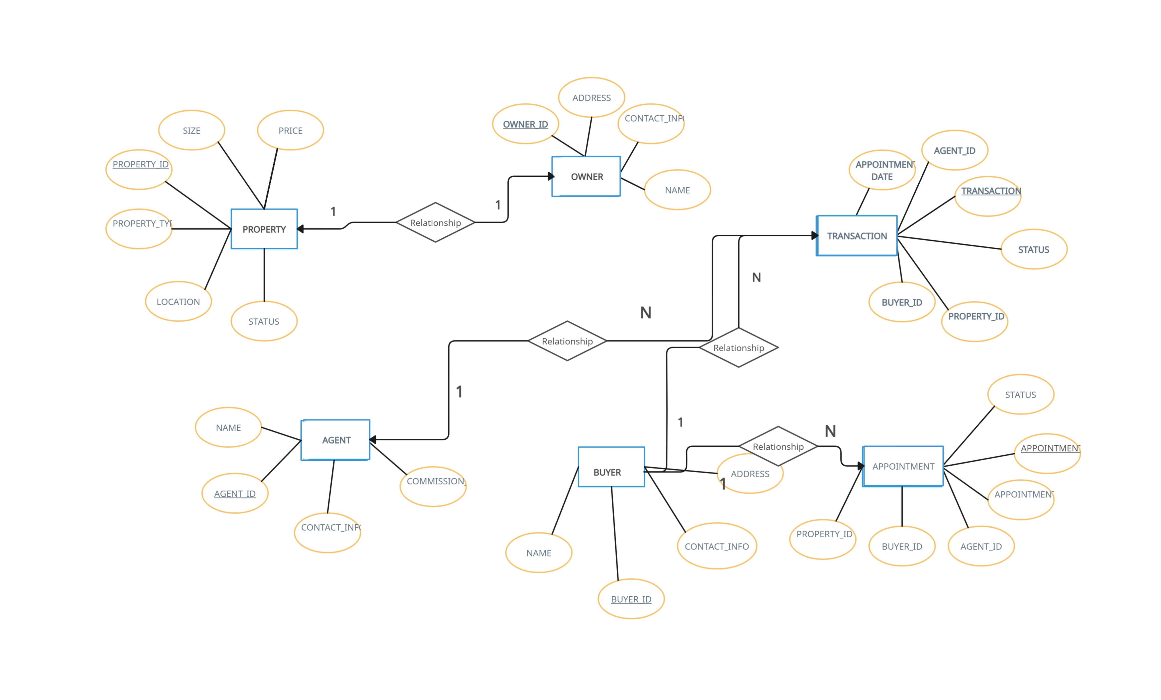

- HARDWARE & SOFTWARE REQUIREMENTS
Basic Hardware Requirements:
- Server:
  - A basic computer with a dual-core processor.
  - 4 GB RAM.
  - Adequate storage
- Client Devices:
  - Standard computers or laptops for users.

Basic Software Requirements:
- Server-Side:
  - MySQL for the database.
  - NODE.JS, EXPRESS framework
- Client-Side:
  - Web browsers (Google Chrome, Mozilla Firefox, or similar).
- Development Tools:
  - Code editor (e.g., Visual Studio Code, Sublime Text).
- Database Management:
  - MySQL Workbench or similar tools for database design and management.

